

LINGAYAS INSTITUTE
OF MANAGEMENT AND TECHNOLOGY
(AUTONOMOUS)
Affiliated to JNTU Kakinada Vijayawada - 520 003, Andhra Pradesh

PROJECT BOOK
IDEA | | | DESIGN | IMPLEMENT | INNOVATE
Project Title | : | ERP with Generative AI Business Assistant
Subject | : | Enterprises Resources Planning (ERP)
Name of the Student(s) | : | Puvvada Mounica
Roll Number(s) | : | 23NA1A5430
Branch | : | Artificial Intelligence and Data Science
Year & Semester | : | IV - 1(4th year 1st Sem)
Academic Year : 2026 2027

Project Guide : Dr. SALLA. PRABHAKARA, M. TECH, PHD

Department : Computer Science and Engineering

Signature of Student(s)

Signature of Guide

ENGINEERING SOLUTIONS | RESEARCH INNOVATION | TECHNOLOGY DEVELOPMENT | SOCIAL IMPACT | SUSTAINABLE FUTURE

LINGAYAS INSTITUTE OF MANAGEMENT AND TECHNOLOGY
(Autonomous)
Approved by AICTE, New Delhi and Permanently Affiliated to JNTUK, Kakinada Accredited by NAAC with “A” Grade | UG-CSE Accredited by NBA Madalavarigudem, Vijayawada - 521212, Andhra Pradesh
Enterprises Resources Planning Project Report Title
ERP with Generative AI Business Assistant
A Mini report submitted in partial fulfilment of the academic requirements of the Mini Project for the award of the degree of
BACHELOR OF TECHNOLOGY

IN
Computer Science and Engineering
Submitted by
P. Mounica (23NA1A5430)

Under the Esteemed Guidance of
Dr. SALLA. PRABHAKARA, M. TECH, PHD

DEPARTMENT OF
COMPUTER SCIENCE AND ENGINEERING
IV-I SEMESTER
ACADEMIC YEAR 2026-27

DECLARATION
I, hereby declare that this project report titled “ERP with Generative AI Business Assistant” is my original work carried out under the guidance of “Dr. SALLA. PRABHAKARA, M. TECH, PHD”, Department of “Computer Science and Engineering”. The work presented in this report has not been submitted to any other institution or agency for the award of any degree, diploma, or certification. All sources of information used in this report have been properly acknowledged.
I further declare that the project work, documentation, screenshots, datasets, code, designs, diagrams, and references included in this report are prepared with academic honesty and are presented to the best of my knowledge.

Place:
Date:

Signature of:

CERTIFICATE
This is to certify that the project report entitled “ERP with Generative AI Business Assistant” is the bona fide work carried out by P. Mounica (23NA1A5430) in partial fulfillment of the requirements for the award of the Degree of Bachelor of Technology in “Computer Science and Engineering “ during the academic year 2026-27 at “Lingaya’s Institute of Management and Technology Vijayawada”, under the guidance of “Dr. SALLA. PRABHAKARA, M. TECH, PHD”.
The work has been reviewed and found suitable for submission as a project report.

Signature of
PROJECT GUIDE
(Dr. SALLA.PRABHAKARA, M. TECH, PHD)
Signature of
HEAD OF THE DEPARTMENT
(prof. K.N.K Ratna Kumar)
Signature of
EXTERNAL EXAMINER

ACKNOWLEDGEMENTS
I would like to articulate my profound gratitude and indebtedness to my guide ,
“Dr. SALLA.PRABHAKARA sir” department of “Computer science and Engineering”, who has always been a constant motivation and driving force throughout the project time in and out as well. It has been a great pleasure for me to get an opportunity to work under his guidance and complete the project successfully.
I would like to thank Head of the department, “Prof. K.N.K Ratna Kumar sir”, department of “Computer science and engineering” of Lingaya’s Institute of Management and Technology for consistently supporting my work throughout the project period with all patience and understanding, giving valuable inputs whenever required for betterment of the work.
I would like to express my gratitude to all the department faculty, department of Computer science engineering for supporting me in all aspects.
I also express my gratitude to our Principal sir, for his encouragement and facilities provided during the course of project.
I would like to articulate our beloved Chairman, Mr. Rajling Gadde sir for his great motivation and encouragement towards project work.
I am grateful to other staff members of department of Computer science engineering and the institute for co-operating with me throughout my project.

Yours sincerely,
P. Mounica
23NA1A5430

Contents
- Title page
- Declaration
- Certificate
- Acknowledgements

Chapter 1 – Introduction
  - Overview
  - Problem Statement
  - Objectives
    - Primary Objectives
    - Secondary Objectives
  - Scope of the Project
    - In Scope
    - Out of Scope
  - Organization of the Report

Chapter 2 – Literature Survey & System Analysis
  - Existing Systems
  - Literature Review
  - Feasibility Study
    - Technical Feasibility
    - Operational Feasibility
    - Economic Feasibility
  - System Requirements
    - Hardware Requirements
    - Software Requirements
  - Functional & Non-Functional Requirements
    - Functional Requirements
    - Non-Functional Requirements
    - User Roles

Chapter 3 – System Design
  - System Architecture
  - Data Flow Diagrams
    - Level 0 – Context Diagram
    - Level 1 – Major Processes
  - Entity Relationship Diagram
  - Use Case Diagram
  - Process Flowcharts
    - Login Process Flowchart

    - Sales Process Steps

    - Software Development Life Cycle
  - Data Dictionary
    - Users Collection
    - Products Collection
    - Sales Collection
    - Employees Collection

Chapter 4 – Implementation
  - Technologies Used
  - Project Structure
  - Module Implementation
    - Login Module
    - Dashboard Module
    - Inventory Management Module
    - Sales Management Module
    - Employee Management Module
  - Sample Code Highlights
    - Currency Formatting Utility
    - Next ID Generation
    - Design Principles Applied
  - Screenshots / Sample Outputs

Chapter 5 – Testing, Results & Conclusion
  - Testing Strategy
  - Test Cases
  - Results & Discussion
  - Advantages & Limitations
    - Advantages
    - Limitations
  - Future Enhancements
  - Conclusion
References
Appendix A – Glossary of Terms Appendix B – Quick User Manual Appendix C – Default Sample Data

List of Tables

Table No. | Title
Table (Hardware) | Hardware Requirements (Section 2.4.1)
Table (Software) | Software Requirements (Section 2.4.2)
Table (Roles) | User Roles (Section 2.5.3)
Table 3.6.1 | Users Collection (erp_users)
Table 3.6.2 | Products Collection (erp_products)
Table 3.6.3 | Sales Collection (erp_sales)
Table 3.6.4 | Employees Collection (erp_employees)
Table (Technologies) | Technologies Used (Section 4.1)
Table 5.1 | Test Case Summary
Table (Test Cases) | Detailed Test Cases (TC-01 to TC-15)
Appendix tables | Glossary, Demo accounts, Sample data lists

List of Figures

Figure No. | Title
Figure 3.1 | System Architecture Diagram
Figure 3.2 | Module Overview Diagram
Figure 3.3 | Data Flow Diagram Level 0 (Context Diagram)
Figure 3.4 | Entity Relationship Diagram
Figure 3.5 | Use Case Diagram
Figure 3.6 | Login Process Flowchart
Figure 3.7 | Software Development Life Cycle Followed
Figure 4.1 | Login Page
Figure 4.2 | Dashboard
Figure 4.3 | Inventory Management
Figure 4.4 | Sales Management
Figure 4.5 | Employee Management

CHAPTER 1 INTRODUCTION

Overview
SmartERP – ERP with Generative AI Business Assistant is a web-based business management application designed to simplify and organize various business operations in a single platform. Enterprise Resource Planning (ERP) systems help organizations manage their important business activities, such as product inventory, sales, employee information, expenses, and reports. Managing these activities manually or through separate applications can be time-consuming and may lead to errors. SmartERP provides a centralized interface to manage these activities efficiently.
The application includes a dashboard that displays important business information, such as total sales, total orders, available products, expenses, sales trends, low-stock alerts, and recent activities. It also provides modules for employee management, product and inventory management, sales and order management, expenses and finance, and reports and analytics. These modules help users organize business records and monitor business performance through a user-friendly interface.
One of the important features of SmartERP is the Generative AI Business Assistant. It is designed to help users obtain business information by asking questions in natural language. For example, users can ask about available stock, monthly sales, total expenses, low-stock products, and top-selling products. The assistant can provide summaries based on the business data available to the application. In the current project implementation, the assistant operates in demonstration mode rather than being connected to a live Generative AI API.
The application is developed using modern web technologies, including React, Vite, JavaScript, and CSS. It provides a responsive user interface that can be accessed through a web browser on desktop and mobile devices. The current implementation uses browser-local storage for business records, allowing users to demonstrate and test the main management features on the same browser.
The main purpose of SmartERP is to provide a simple, accessible, and organized platform for business management. By combining essential ERP functions with an AI-assisted interface, the project demonstrates how modern web technologies can support business operations, improve data accessibility, and assist users in understanding business information.

Problem Statement
Businesses need to manage several activities, including inventory maintenance, sales tracking, employee records, expense management, and business reporting. When these activities are handled manually or through separate systems, maintaining accurate and updated information becomes difficult. Users may spend considerable time searching for records, calculating totals, checking stock availability, and preparing business reports.
Traditional methods of business management may also result in duplicate records, calculation errors, delayed updates, and difficulty in identifying low-stock products. In addition, understanding business performance often requires users to examine multiple records and reports individually. These problems can affect the efficiency of daily operations and make it harder to access important business information quickly.
Another challenge is that users may need to navigate multiple screens to find specific information. For example, identifying the best-selling product or comparing monthly sales may require manually reviewing sales records and calculating totals. A simple interface that organizes business data and supports quick information retrieval can reduce this effort.
Therefore, the SmartERP project aims to address these challenges by providing a centralized web-based platform for managing major business activities. It combines inventory, sales, employee, expense, and reporting features with a demonstration-mode AI Business Assistant. The system is intended to simplify record management, display useful business summaries, and make common business information easier to access.

1.3 Objectives

The main objective of SmartERP is to develop a user-friendly ERP application that brings essential business management functions together in a single web-based platform. The application aims to simplify routine business operations, organize records, and present relevant business information through a dashboard and reporting interface.

1.3.1 Primary Objectives
The primary objectives of the project are:
- To develop a centralized dashboard for displaying important business information and performance indicators.
- To implement product and inventory management features for maintaining product details, prices, quantities, and stock availability.
- To provide sales and order management features for creating orders, calculating totals, and tracking order status.
- To develop an employee management module for maintaining employee details and records.
- To provide an expense management module for recording and organizing business expenses.
- To generate business summaries and visual reports to help users understand sales, inventory, and expenses.
- To develop a Generative AI Business Assistant interface that allows users to ask business-related questions in natural language.

1.3.2 Secondary Objectives
The secondary objectives of the project are:
- To design a clean, modern, and responsive user interface.
- To provide search, filtering, and record management options wherever applicable.
- To display low-stock alerts to help users identify products that may require replenishment.
- To automate basic calculations, including order totals and currency formatting.
- To improve the accessibility of business information through dashboard cards, charts, and summaries.
- To use reusable components and maintain a consistent design across application modules.
- To provide a foundation for future integration with a secure backend, centralized database, and live Generative AI services.

1.4 Scope of the Project
The scope of the SmartERP project covers the development of a web-based application for managing essential business activities. It focuses on providing a common interface for product inventory, sales, employees, expenses, and business reports. The project also demonstrates how an AI-style conversational interface can help users retrieve and understand business information.
The current application is primarily intended for educational and demonstration purposes. It demonstrates the main user interface, record management workflows, calculations, and business summaries. The current implementation uses browser-local storage rather than a shared production database. The Generative AI Business Assistant is also provided in demonstration mode and is not connected to a live AI service.

1.4.1 In Scope
The following features are included within the scope of the project:
- Dashboard Management: Display business summary cards, sales charts, product categories, low-stock alerts, recent activities, and quick actions.
- Employee Management: Add, view, edit, delete, search, and manage employee records.
- Product and Inventory Management: Maintain product information, including product names, categories, prices, quantities, and stock availability.
- Sales and Order Management: Create customer orders, calculate order amounts, manage order statuses, and demonstrate inventory updates when orders are completed.
- Expenses and Finance: Record and manage business expenses and display expense summaries.
- Reports and Analytics: Present business information through charts, summaries, and supported report-export features.
- AI Business Assistant: Provide a chat interface for asking business-related questions and displaying demonstration responses based on available application data.
- Settings: Provide options for managing supported business preferences and application settings.
- Responsive Interface: Support the use of the application through modern web browsers on different screen sizes.
1.4.2 Out of Scope
The following features are outside the scope of the current implementation:
- Integration with a live Generative AI API for production-level AI responses.
- Centralized cloud database storage and synchronization across multiple devices.
- Production-grade authentication, role-based access control, and multi-user security.
- Integration with external accounting, payroll, banking, or enterprise systems.
- Live payment gateway integration for processing financial transactions.
- Advanced forecasting, machine learning-based demand prediction, and automated business optimization.
- Production deployment with enterprise-level monitoring, backups, and security infrastructure.
These features may be considered in future versions of the application to improve scalability, security, and functionality.
1.5 Organization of the Report
This project report is organized into five chapters. Each chapter explains a different stage of the development of the SmartERP application, from the initial problem identification to implementation, testing, and conclusions.

CHAPTER 2
LITERATURE SURVEY & SYSTEM ANALYSIS
2.1 Existing Systems
Business organizations use different methods and software applications to manage their daily activities, such as inventory management, sales tracking, employee records, expense monitoring, and report generation. These methods range from manual record keeping to advanced Enterprise Resource Planning (ERP) systems.
In traditional business environments, information is often maintained using registers, spreadsheets, or separate software applications. Although these methods are useful for basic record management, they can become difficult to maintain when the amount of business data increases. Users may need to enter the same information repeatedly, calculate totals manually, and search through multiple files to obtain the required details.
Traditional ERP systems provide integrated solutions for managing various business operations. However, some systems may require paid subscriptions, extensive configuration, specialized training, or additional modules to meet specific organizational requirements. Small businesses and educational projects may find these systems complex for their basic needs.
Another limitation of conventional business management systems is that users generally need to navigate through reports and tables to understand business performance. They may not provide a simple conversational interface for asking questions about sales, inventory, or expenses.
SmartERP is designed as a simplified web-based business management application that brings several essential business functions into one interface. It includes dashboard summaries, product and inventory management, sales and order management, employee management, expense tracking, reports, and an AI Business Assistant demonstration interface.
The following table compares common existing approaches with the proposed SmartERP system.

Feature | Manual Records / Spreadsheets | Traditional ERP Systems | SmartERP
Data management | Manual entry | Integrated database | Browser-local records in the current implementation
Inventory tracking | Manual updates | Automated features, depending on configuration | Product and stock management
Sales management | Separate records | Integrated order processing | Order creation and total calculations
Employee records | Registers or spreadsheets | Employee management modules | Employee record management
Business reports | Manual calculations | Reporting and analytics tools | Dashboard summaries, charts, and supported exports
Conversational assistant | Usually unavailable | Depends on the system | Demonstration-mode business assistant
User interface | Basic forms or spreadsheets | Varies by product | Modern, responsive web interface

The comparison shows that SmartERP aims to combine commonly required business management features in a simple and accessible interface. However, its current browser-local storage and demonstration-mode assistant distinguish it from fully deployed enterprise ERP systems.

2.2 Literature Review
Enterprise Resource Planning systems are widely used to integrate business processes and organize information within an organization. ERP systems can combine functions such as sales, inventory, finance, human resources, and reporting into a common system. This integration can reduce information duplication and help users access relevant business records more efficiently.
Inventory management is an important part of business operations. It involves maintaining product information, tracking stock quantities, and identifying products that need replenishment. A well-designed inventory system helps users monitor available stock and reduce errors associated with manual record keeping. SmartERP applies these concepts through product records, quantity tracking, and low-stock alerts.
Sales management systems support customer order creation, calculation of order amounts, and tracking of order status. Automated calculations reduce the need for repeated manual calculations. In SmartERP, users can manage orders and view business summaries, while inventory updates can be demonstrated when an order is completed.
Business analytics and data visualization help users interpret numerical information through charts, tables, and summary indicators. Instead of reviewing large numbers of individual records, users can examine sales trends, product categories, and expense summaries. SmartERP uses dashboard cards and charts to make business information easier to understand.
Generative Artificial Intelligence is an emerging technology that can generate responses from natural-language instructions. When connected securely to appropriate business data and a suitable AI model, a business assistant can help users summarize information, answer questions, and prepare reports. For example, a user may ask about monthly sales, available stock, or products with low inventory.
The effectiveness of an AI business assistant depends on the accuracy of the underlying data, suitable access controls, and the quality of its integration with the application. Numerical results should be calculated from actual records rather than generated without verification. In the current SmartERP implementation, the assistant is available in demonstration mode; live Generative AI integration remains a possible future enhancement.
Modern frontend technologies such as React support reusable user interface components and dynamic page updates. Vite provides a development and build environment for frontend applications, while JavaScript supports application logic and calculations. CSS is used to create responsive layouts and consistent visual styling.
Based on these concepts, SmartERP combines basic ERP functionality, data visualization, responsive web design, and a demonstration-mode conversational assistant in one application. The project provides a foundation for exploring how integrated business management interfaces can simplify common business tasks.

2.3 Feasibility Study
A feasibility study evaluates whether a proposed project can be developed and used with the available resources, technologies, and budget. The feasibility of SmartERP is evaluated in terms of technical, operational, and economic factors.

2.3.1 Technical Feasibility
SmartERP is technically feasible because it uses widely available web development technologies. The application is developed using React, Vite, JavaScript, and CSS. These technologies support the creation of interactive web interfaces, reusable components, responsive layouts, and client-side business logic.
The project can be developed and executed using Visual Studio Code, Node.js, npm, and a modern web browser. These tools are readily available and are suitable for educational software development.
The current implementation uses browser-local storage for maintaining application records. This approach allows basic data persistence in the same browser without requiring a separate database server. However, it does not provide centralized data sharing across devices and users.
The AI Business Assistant currently operates in demonstration mode. Connecting it to a live AI service would require a supported API integration, secure backend processing, appropriate credentials, and access controls.
Therefore, the project is technically feasible in its current demonstration form. Additional backend and database infrastructure would be required to transform it into a production-ready, multi-user ERP system.

2.3.2 Operational Feasibility
Operational feasibility determines whether users can operate the application conveniently and whether it supports their basic business management requirements.
SmartERP provides a dashboard with clear navigation and separate modules for employees, inventory, sales, expenses, reports, and the business assistant. Users can access relevant features through the sidebar and interact with records using forms, tables, search options, and action buttons.
The interface is designed to reduce the effort required to locate and manage business information. Dashboard summaries and visual reports help users understand important business indicators without reviewing every record individually.
The application runs in a web browser, making it convenient to demonstrate without installing a separate desktop application. Its responsive layout is intended to support different screen sizes.
Since the current project uses browser-local storage, its operation is best suited to demonstrations and individual-browser usage. Multi-user workflows, shared records, and production authentication would require further development.
Thus, SmartERP is operationally feasible for educational demonstrations and basic business management workflows.

2.3.3 Economic Feasibility
Economic feasibility examines the cost required to develop, operate, and maintain the application.
SmartERP uses commonly available development tools, including Visual Studio Code, React, Vite, JavaScript, and CSS. These technologies can be used without purchasing commercial development licenses. The project can be developed and tested on an existing laptop or desktop computer with a supported browser.
The current local implementation does not require a paid database server or a live AI API to demonstrate its basic features. This reduces the initial development cost.
However, future production deployment may involve hosting charges, database services, AI API usage, domain registration, monitoring, and maintenance expenses. The actual cost would depend on the selected service providers and application usage.
Therefore, SmartERP is economically feasible as a student project and demonstration application because it can be developed using accessible tools and existing hardware.

2.4 System Requirements
System requirements specify the hardware and software necessary to develop, execute, and test the SmartERP application.

2.4.1 Hardware Requirements
The following hardware configuration is suitable for development and testing.
Component | Minimum Requirement
Processor | Dual-core processor or equivalent
RAM | 4 GB
Storage | At least 1 GB of free space for the project and dependencies
Display | Standard laptop or desktop display
Input Devices | Keyboard and mouse or touchpad
Network | Internet connection for downloading dependencies and accessing online resources

A computer with higher RAM and a modern processor is recommended for smoother development, testing, and multitasking.

2.4.2 Software Requirements
Software | Purpose
Operating System | Windows, Linux, or macOS
Visual Studio Code | Writing and editing project code
Node.js | Running the JavaScript development environment
npm | Installing and managing project dependencies
React | Building reusable user interface components
Vite | Running the development server and building the frontend
JavaScript | Implementing application logic and calculations
CSS | Designing responsive layouts and visual styling
Web Browser | Running and testing the application

The exact versions of Node.js and the project dependencies should be compatible with the application's package.json configuration.

2.5 Functional & Non-Functional Requirements
System requirements are classified into functional and non-functional requirements. Functional requirements describe the operations that the application must perform, while non-functional requirements describe the expected quality and usability of the system.

2.5.1 Functional Requirements
The major functional requirements of SmartERP are listed below.
- Dashboard: The system should display business summary cards, charts, recent activities, and low-stock alerts based on the available application data.
- Employee Management: The system should allow users to add, view, edit, delete, search, and manage employee records.
- Product Management: The system should maintain product names, SKUs, categories, prices, quantities, and descriptions.
- Inventory Tracking: The system should display stock quantities and identify products that meet the configured low-stock condition.
- Sales Management: The system should support order creation, product selection, quantity entry, automatic total calculations, and order-status management.
- Inventory Updates: The system should demonstrate stock updates when orders are completed, according to the implemented order logic.
- Expense Management: The system should allow users to record and manage expense details, including categories, amounts, dates, and descriptions.
- Reports and Analytics: The system should display business summaries and charts and provide supported export options.
- AI Business Assistant: The system should provide a conversational interface for business-related questions and display demonstration responses.
- Settings: The system should provide access to supported business preferences, such as the low-stock threshold.
- Data Persistence: The system should preserve supported records using browser-local storage.
- User Interface: The system should provide consistent navigation and responsive layouts for different screen sizes.
These requirements describe the intended and demonstrated functionality of the current application. Live AI services, centralized storage, and production authentication are not considered implemented unless separately integrated and verified.

2.5.2 Non-Functional Requirements
Usability: The application should provide clear navigation, readable text, understandable labels, and simple forms so that users can perform common business operations easily.
Performance: The application should respond promptly to normal user actions, such as opening modules, searching records, calculating order totals, and displaying dashboard summaries, subject to the available device and data volume.
Reliability: Calculations and record updates should behave consistently. Input validation and confirmation messages should help reduce common user errors.
Maintainability: The source code should be organized into reusable components and clearly structured modules so that future changes can be made more easily.
Portability: The application should run in modern web browsers on commonly used desktop and mobile operating systems.
Responsiveness: The interface should adjust to different screen sizes and remain usable on desktops, tablets, and mobile devices.
Data Persistence: Browser-local storage should preserve supported records within the same browser environment. It should not be treated as a secure, centralized database or as a backup system.
Security: Sensitive production data would require secure authentication, authorization, backend validation, and appropriate data protection measures. These features require further implementation before the application can be used as a production ERP system.
Scalability: The current implementation is intended for demonstration and basic usage. Supporting larger datasets, multiple users, and concurrent access would require a centralized backend and database architecture.

2.5.3 User Roles
User roles describe the categories of people who may interact with the SmartERP application.
1. Administrator
An administrator in a future production deployment may be responsible for managing employees, products, orders, expenses, business settings, and access permissions. The administrator may also review reports and monitor overall business activities. These privileges require appropriate authentication and authorization to be implemented.
2. Business User
A business user may use the application to review dashboard information, maintain product records, manage orders, record expenses, and view business summaries, depending on the permissions assigned.
3. AI Business Assistant User
An authorized user may interact with the assistant by asking questions about business information and requesting summaries or reports. In the current implementation, the assistant operates in demonstration mode and should not be considered a live AI service.
In the current browser-based demonstration, these roles describe the intended users of the system rather than a fully enforced role-based access-control mechanism. Production deployment would require authenticated accounts and server-side permission checks.

CHAPTER 3
SYSTEM DESIGN
3.1 System Architecture
System architecture describes the overall structure of the SmartERP – ERP with Generative AI Business Assistant. It explains how users interact with the application, how business operations are processed, and how information is stored and retrieved.
SmartERP follows a frontend-based web application architecture. The user interacts with the application through a web browser. The frontend is developed using React.js, JavaScript, CSS, and Vite. React components display the dashboard and different business modules, while JavaScript handles calculations, form inputs, data processing, and other operations.
The application uses browser Local Storage to retain supported data on the same browser. The AI Business Assistant included in the current version operates in demo mode and provides simulated assistance. A live AI API, centralized database, and production backend are considered future enhancements unless separately implemented.
The main components of the system are:
- User Interface: Provides screens for the dashboard, employees, inventory, sales, expenses, reports, and settings.
- Business Logic: Processes user inputs, performs calculations, and manages business operations.
- Local Storage: Stores supported application data in the user's browser.
- AI Business Assistant: Provides demo-based business assistance using the available application information.
- Reports and Analytics: Presents business summaries and calculated information in a readable format.

System Architecture Diagram
Figure 3.1: System Architecture of SmartERP
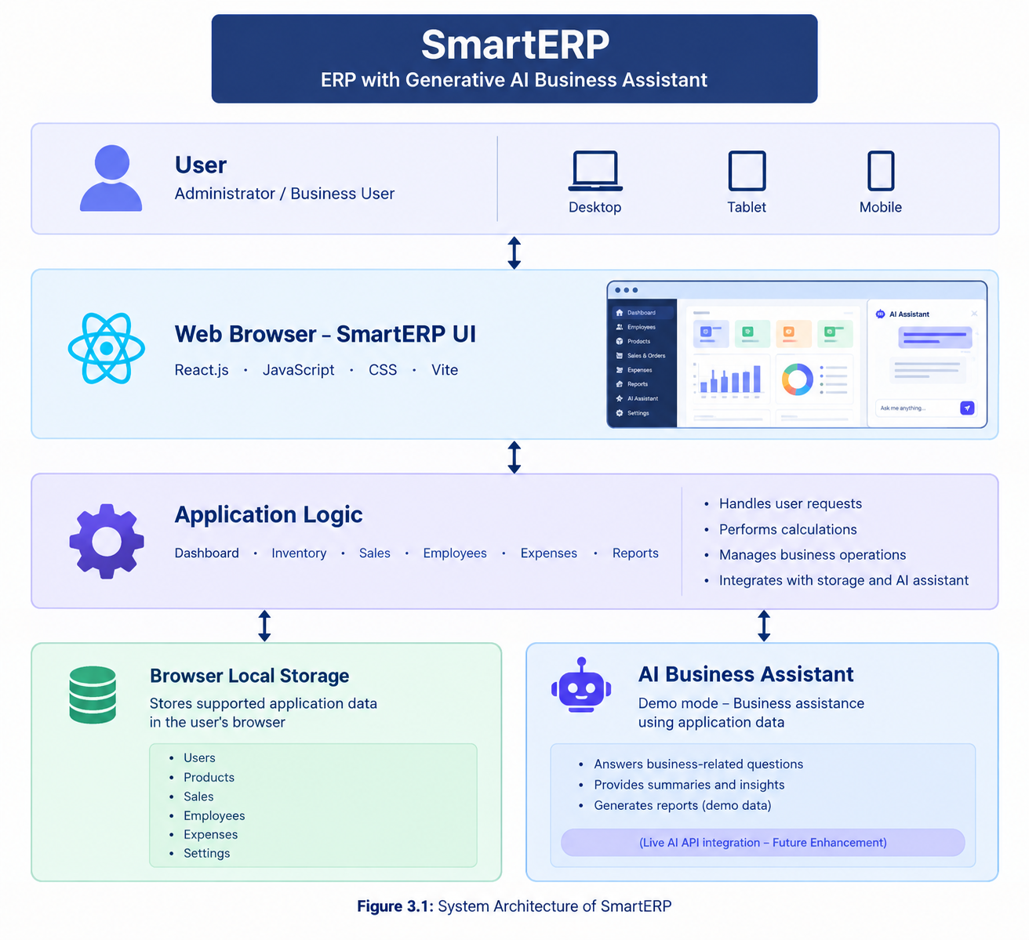
3.2 Data Flow Diagrams
A Data Flow Diagram (DFD) represents how information moves through a system. It identifies the external entities, processes, data storage, and information exchanged between them.

3.2.1 Level 0 – Context Diagram
The Level 0 DFD represents SmartERP as a single process and shows its interaction with the user. The user provides information such as product details, employee details, sales entries, and expense details. The system processes the information and displays dashboards, summaries, records, and reports.

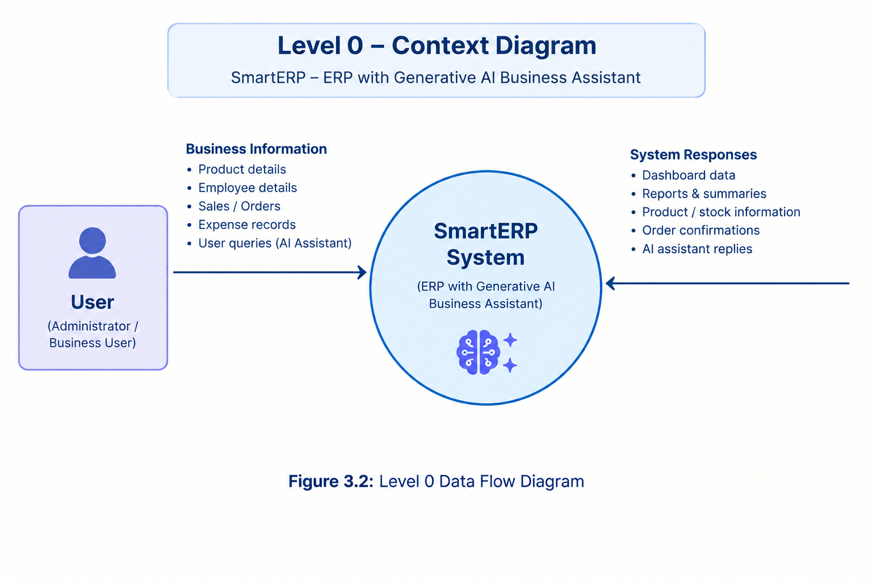

3.2.2 Level 1 – Major Processes
The Level 1 DFD divides the main system into smaller processes. It explains how the user interacts with individual modules and how the application stores and retrieves data.
The major processes are:
- Dashboard Management: Displays business summaries and key information.
- Inventory Management: Handles product information, stock quantities, and inventory updates.
- Sales Management: Processes sales entries and calculates totals.
- Employee Management: Maintains employee details.
- Expense Management: Records and summarizes expenses.
- Reports and Analytics: Displays summaries based on available business data.
- AI Business Assistant: Provides demo-based responses to business-related queries.

3.3 Entity Relationship Diagram
An Entity Relationship Diagram (ERD) represents the data entities in a system and the relationships between them. For SmartERP, the main conceptual entities are Users, Products, Sales, Employees, and Expenses.
The following entities describe the information managed by the application:
- Users: Represents people who interact with the system. User roles are conceptual unless authentication and role-based access control have been implemented.
- Products: Stores product names, categories, prices, and available stock details.
- Sales: Represents sales transactions, including relevant product details, quantities, and totals.
- Employees: Stores employee names, contact information, designations, and other supported details.
- Expenses: Stores expense descriptions, categories, amounts, and dates.

Figure 3.3: Level 1 Data Flow Diagram
This is a simplified logical representation of the application's modules. In the actual implementation, the modules access supported data through frontend application logic and browser Local Storage; they do not communicate through a separate database server.

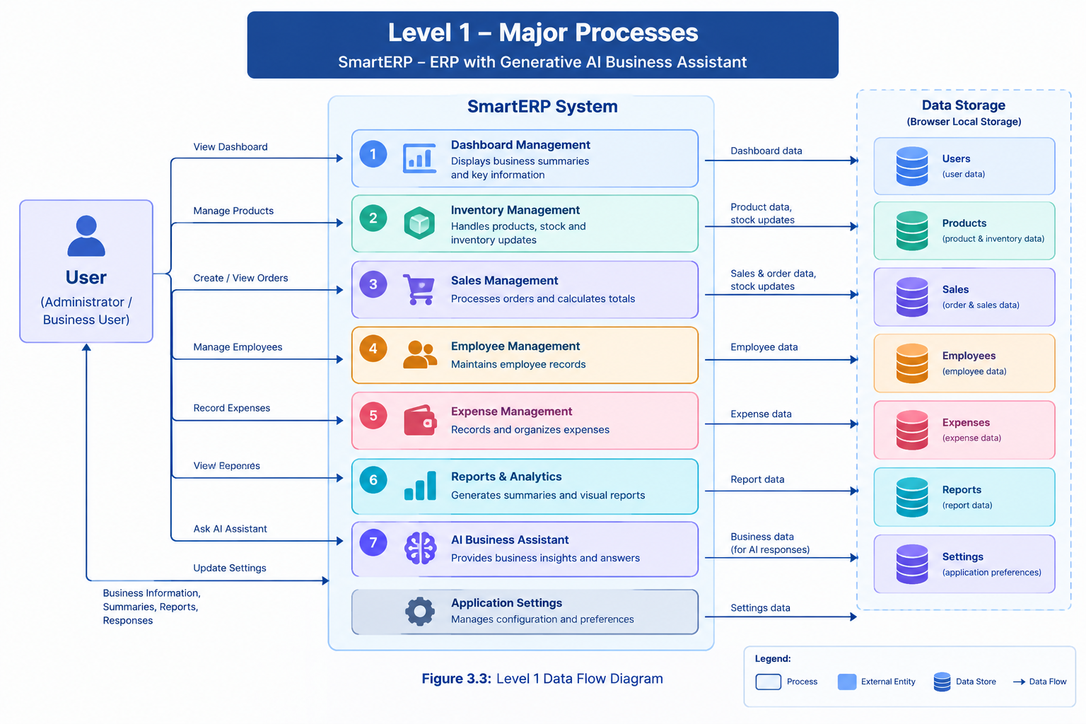
3.4 Use Case Diagram
A Use Case Diagram represents the interactions between users and the system. It identifies the main actions that can be performed through SmartERP.
The primary actor is the Business User, who accesses the application's available modules. An administrator can be shown as a separate actor in the conceptual diagram, but separate administrator permissions should only be claimed if they are implemented.
The main use cases are:
- View dashboard information.
- Manage inventory and product records.
- Record and review sales.
- Manage employee information.
- Record and review expenses.
- View reports and analytics.
- Interact with the AI Business Assistant.
- Update available application settings.
Figure 3.4: Conceptual Entity Relationship Diagram
The diagram is a conceptual representation of the business information. Since the current version uses browser Local Storage rather than a relational database, these entities are logical data groups and are not necessarily actual database tables or collections. The exact relationships and fields should match the records supported by the application.
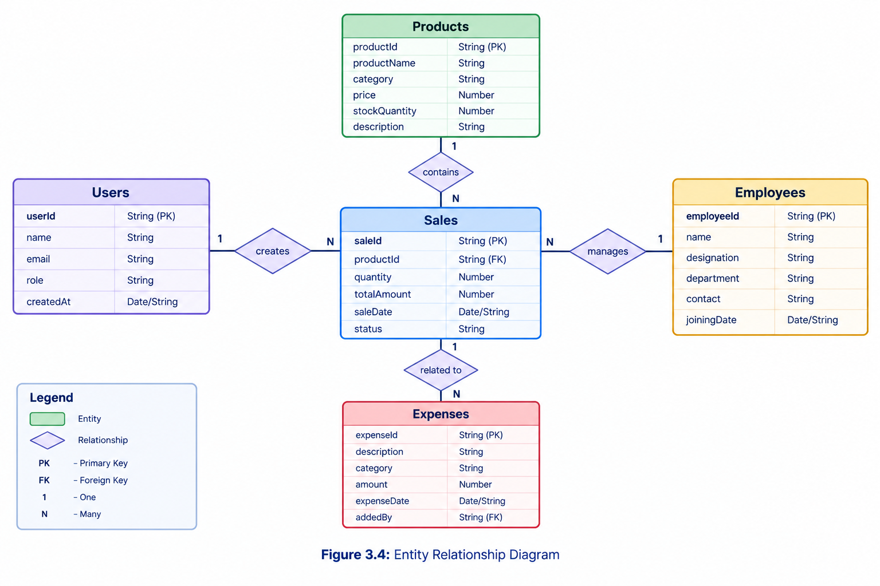

3.5 Process Flowcharts
A flowchart represents the sequence of steps involved in completing a task. It uses standard symbols such as ovals for start and end points, rectangles for processes, and diamonds for decisions.

3.5.1 Login Process Flowchart
The login flowchart represents the general sequence of accessing an application. The actual SmartERP starter should not be described as having secure, backend-verified login unless that feature has been implemented.
For the current version, the diagram below represents a proposed login process for a future authenticated version.
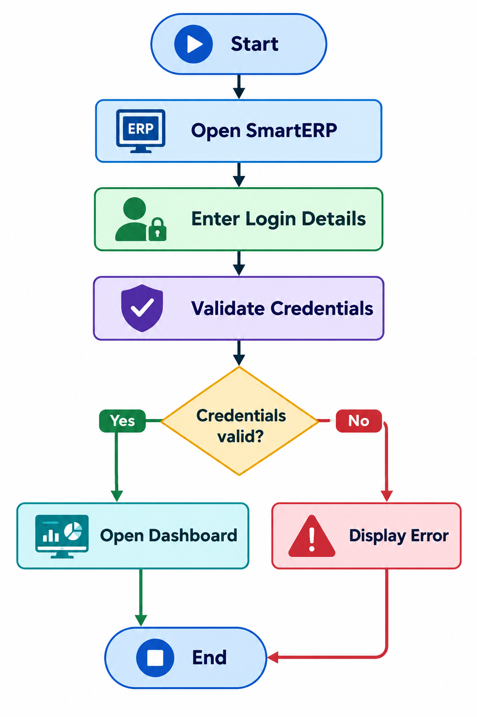

3.5.2 Sales Process Steps
The sales process describes how a business user records a sale and reviews the resulting information.
The steps are:
- The user opens the Sales Management module.
- The user enters the required sales information.
- The application validates the entered values.
- The application calculates the sale total based on the available pricing and quantity information.
- The user saves the sale record.
- The application stores the supported information in browser Local Storage.
- The dashboard or reports may reflect the updated information, depending on the application's implemented calculations.
- The process ends after the sale has been recorded.
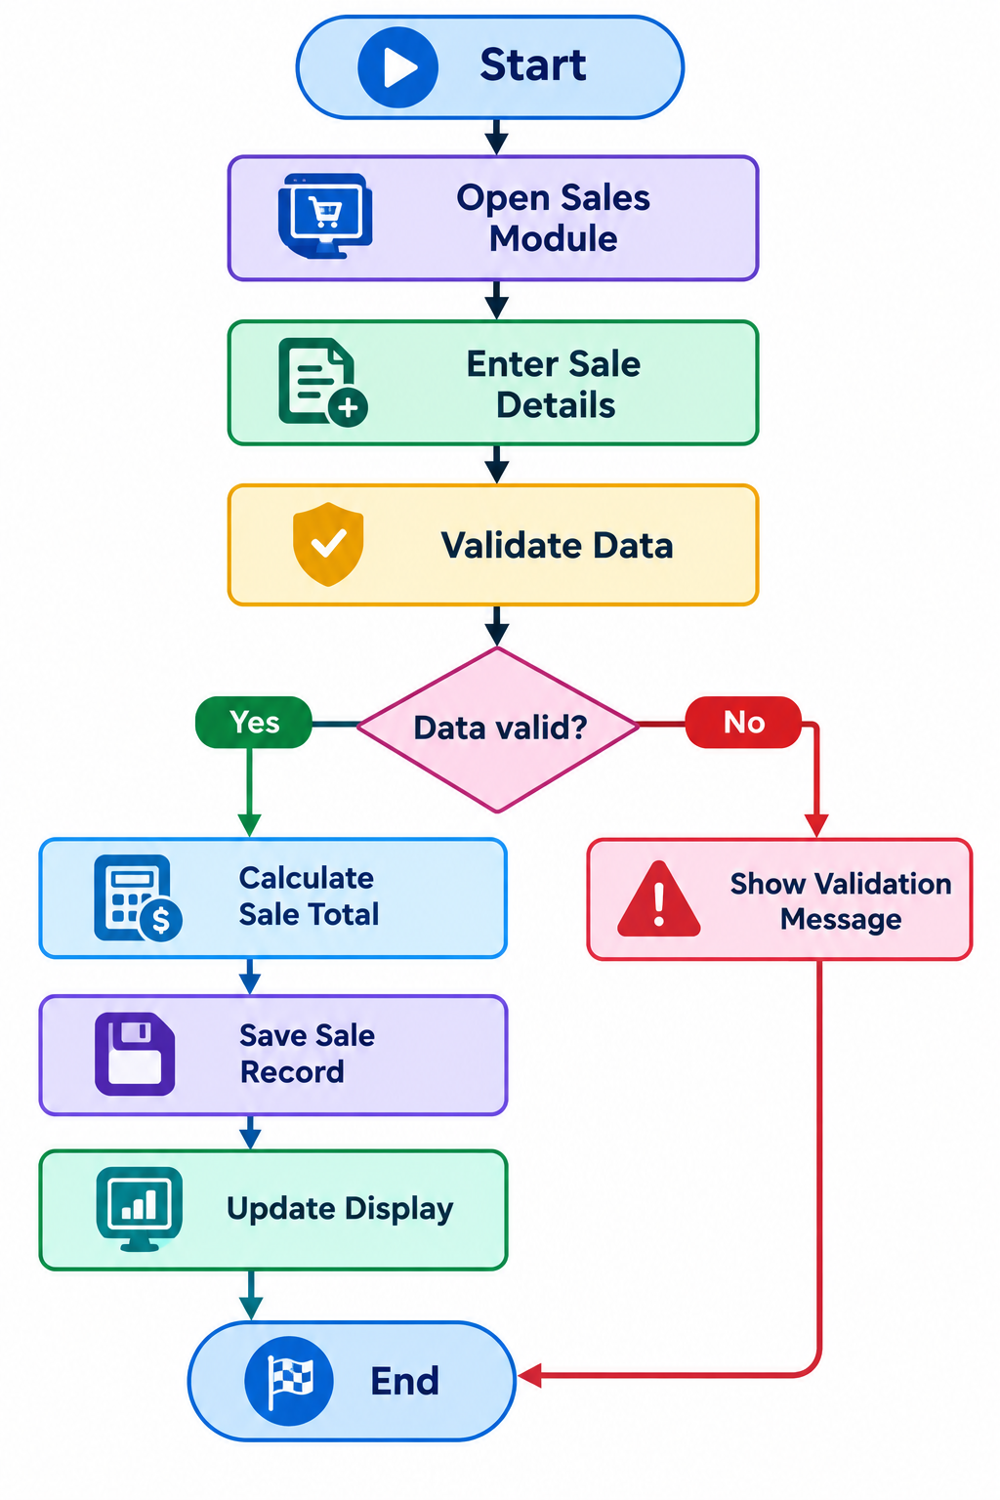

Figure 3.6: Proposed Login Process Flowchart

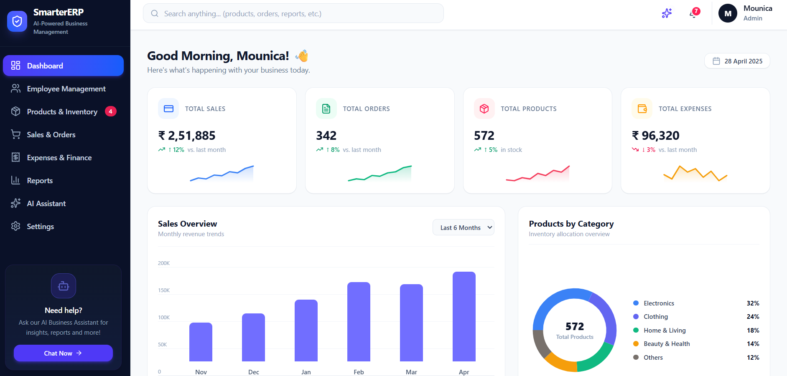

3.6 Data Dictionary
A Data Dictionary describes the fields used to represent information in the system. It includes field names, data types, and purposes.
For the current SmartERP version, the following tables describe conceptual data entities. The exact field names and data types must be adjusted to match the actual application code. Browser Local Storage stores key-value data; it does not automatically create database collections.

3.6.1 Users Collection
The Users entity represents user information in a proposed authenticated system.
Field Name | Data Type | Description
userId | String | Unique user identifier
name | String | User's name
email | String | User's email address
role | String | Conceptual user role
createdAt | Date/String | Record creation date

Table 3.1: Users Data Dictionary
These fields describe a proposed user entity. They should not be treated as proof that a secure user database or login system currently exists.

3.6.2 Products Collection
The Products entity represents the products managed through inventory.
Field Name | Data Type | Description
Product Id | String | Unique product identifier
Product Name | String | Name of the product
Category | String | Product category
Price | Number | Product selling price
Stock Quantity | Number | Available stock quantity

Table 3.2: Products Data Dictionary
The product information is used for displaying inventory records and supporting relevant stock and sales calculations.

3.6.3 Sales Collection
The Sales entity represents sales transactions recorded by the business user.
Field Name | Data Type | Description
Sale Id | String | Unique sale identifier
Product Id | String | Related product identifier, if applicable
Quantity | Number | Quantity sold
Total Amount | Number | Total sale amount
Sale Date | Date/String | Date of the sale

Table 3.3: Sales Data Dictionary
The sales data can be used to calculate sales summaries and display relevant information in reports. The exact transaction structure depends on how the current sales module is implemented.

3.6.4 Employees Collection
The Employees entity represents employee information maintained in the system.

Table 3.4: Employees Data Dictionary
These fields help organize employee information and support the employee management module. Fields not supported by the actual application should be removed or identified as proposed additions.

Field Name | Data Type | Description
Employee Id | String | Unique employee identifier
name | String | Employee's name
designation | String | Employee's job role
contact | String | Employee contact information
department | String | Employee's department, if supported

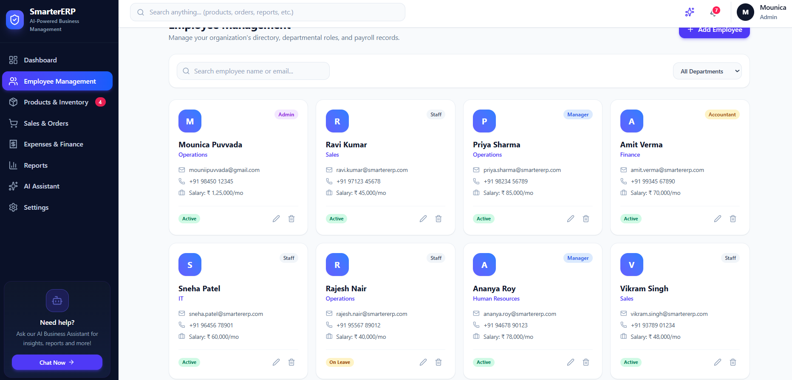

Figure 3.7: Sales Process Flowchart
The flowchart represents the intended sales workflow. Actual inventory deduction, invoice generation, or payment processing should only be included if those features are implemented in the current application.

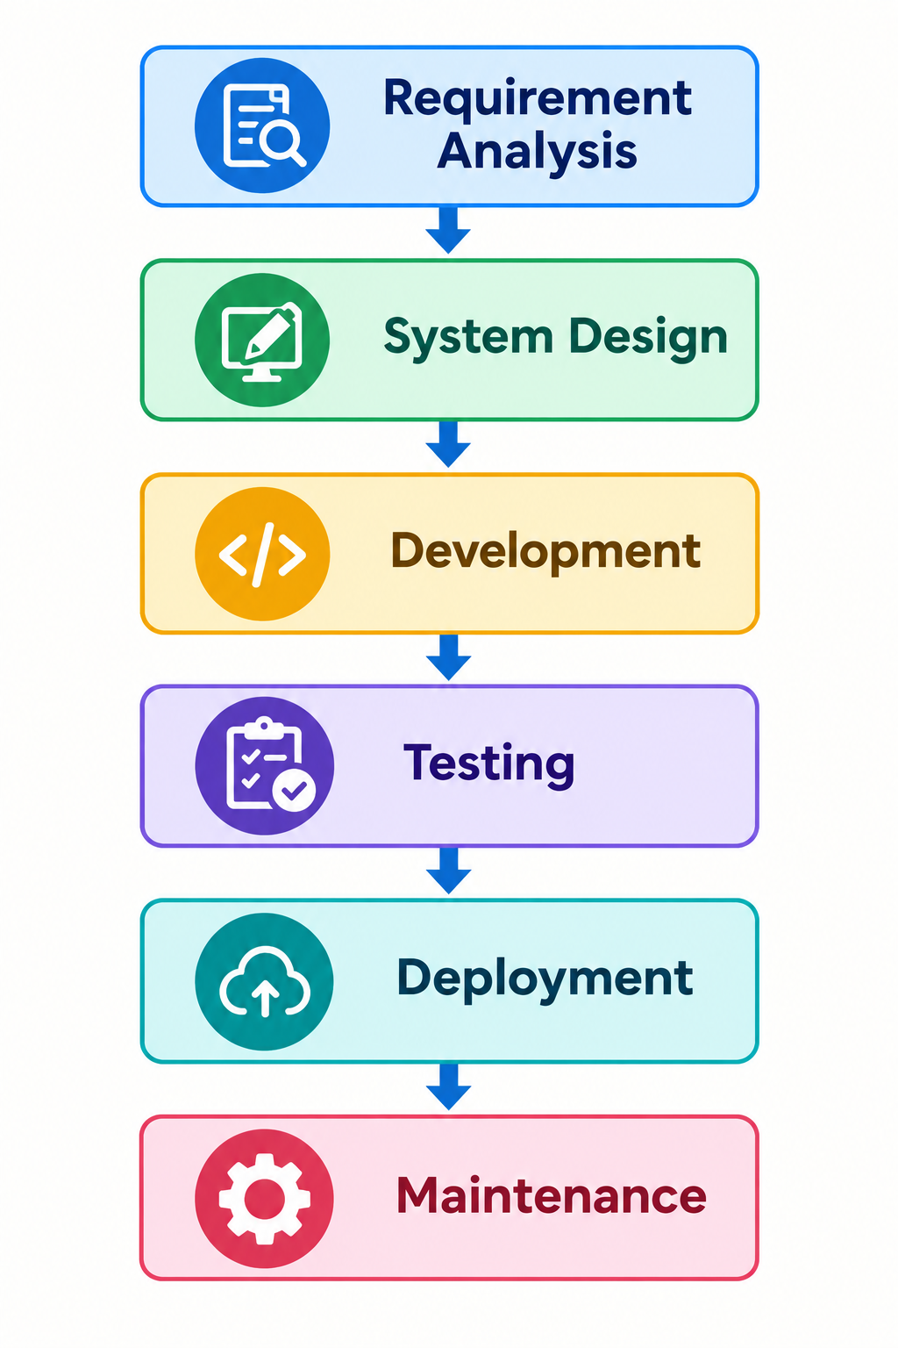

Figure 3.8: Software Development Life Cycle
These stages provide a structured approach to building, checking, and improving SmartERP.

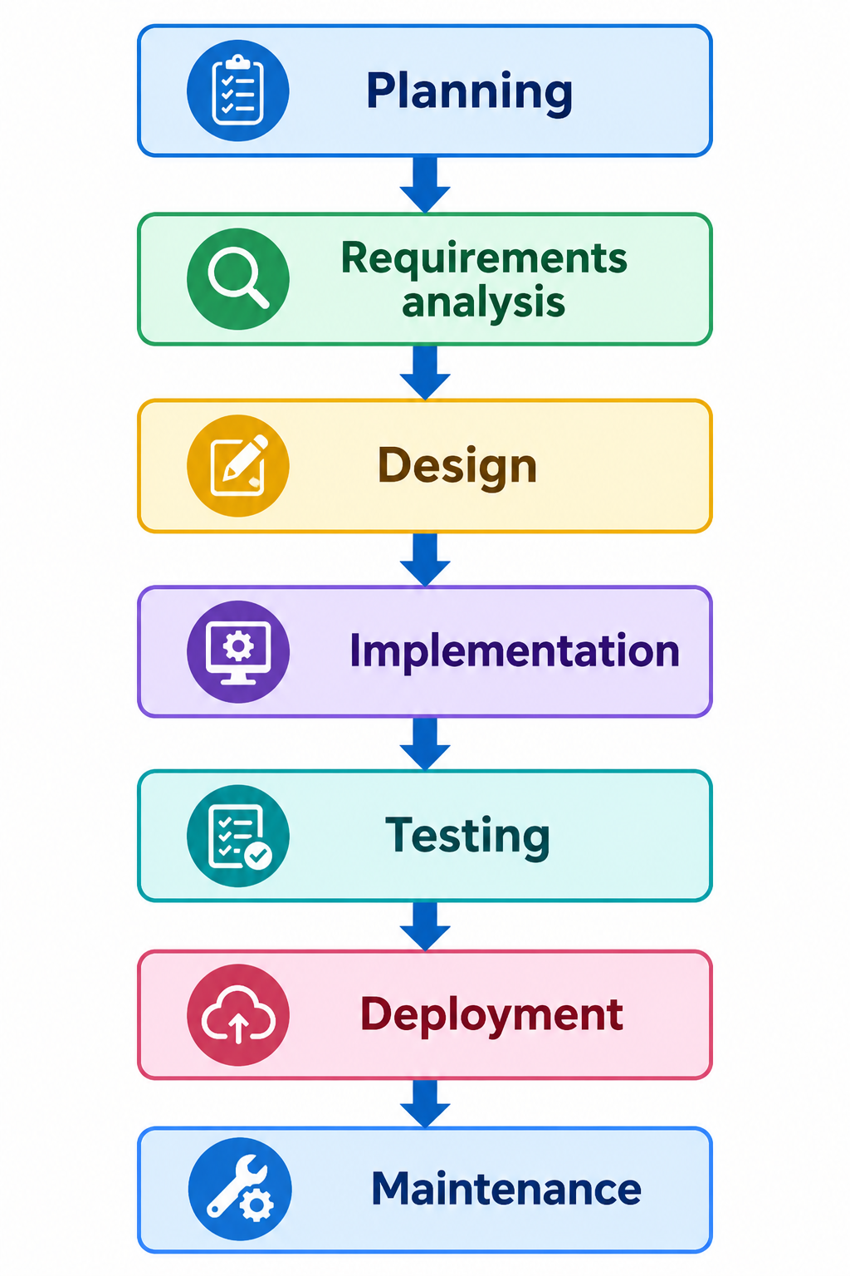

CHAPTER 4
IMPLEMENTATION
4.1 Introduction
Implementation is the process of converting the system design into a working application. The SmartERP project is developed to provide a simple and user-friendly interface for managing business-related information. It combines Enterprise Resource Planning (ERP) features with a demo Generative AI business assistant to help users access business information easily.
The application provides a dashboard and different modules for managing business activities. The frontend is developed using React.js, and the user interface is styled using CSS. Vite is used as the development and build tool. Browser Local Storage is used to retain supported application data on the user's browser. The AI assistant is demonstrated in demo mode.

4.2 Technologies Used
The following technologies are used in the development of the SmartERP application.
Technology | Purpose
React.js | To develop reusable UI components and interactive pages
JavaScript | To implement application logic and user interactions
HTML5 | To structure the web pages
CSS3 | To style the interface and make it responsive
Vite | To run the development server and build the frontend
Browser Local Storage | To store supported application data locally in the browser
Generative AI Assistant (Demo Mode) | To demonstrate a business assistant interface for business-related queries

4.3 Project Structure
The SmartERP project is organized into files and folders to make the application easier to develop, maintain, and update. The project contains frontend components, pages, styling files, and configuration files.
The exact folder structure may vary depending on the final version of the project.
Example project structure:
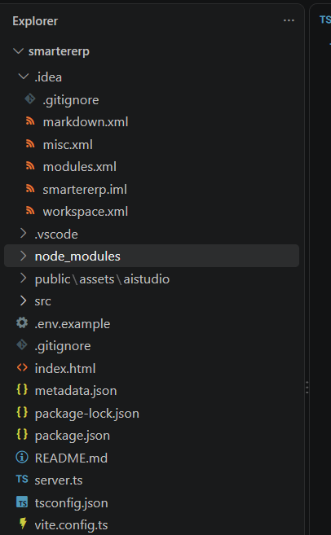

4.4 Modules of the System
SmartERP is organized into modules that represent different business operations. The availability and functionality of each module depend on the implemented version of the application.

4.4.1 Dashboard Module
The Dashboard module provides an overview of business information in a single interface. It can display summary cards, key business indicators, and shortcuts to other modules. This helps users quickly understand the general status of business activities without navigating through every section.

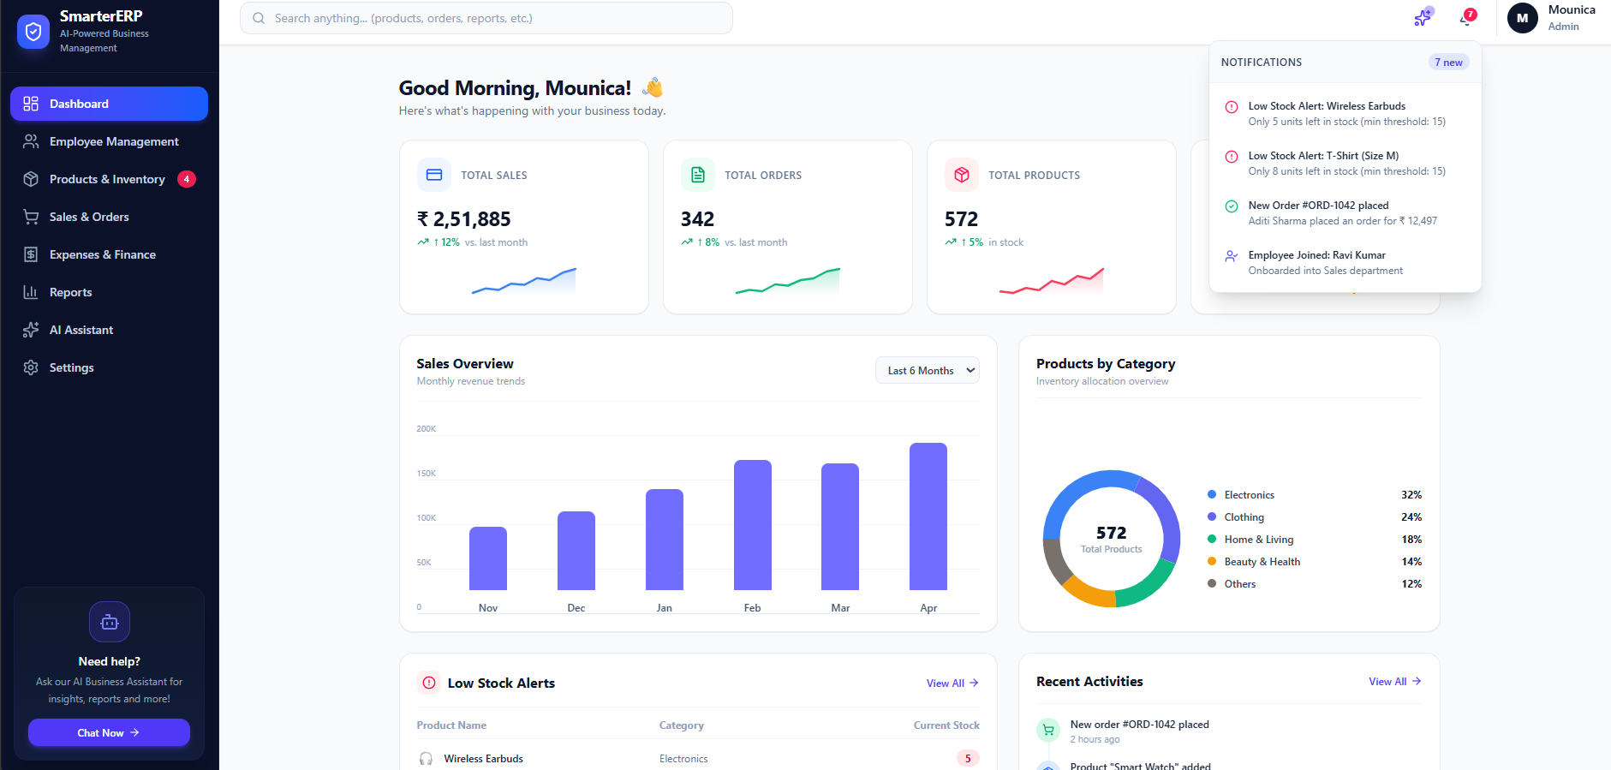

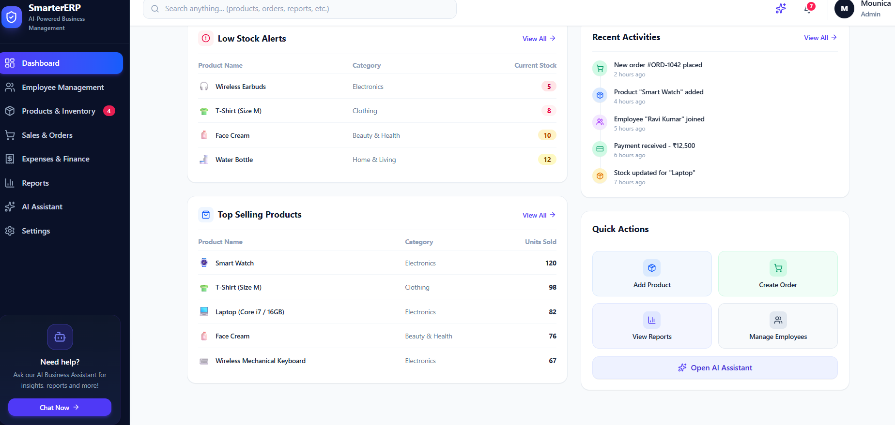

4.4.2 Product and Inventory Module
The Product and Inventory module is intended to organize product-related information. It can display product names, categories, prices, and stock quantities when these features are supported by the application. This module helps users view and manage product information conveniently.

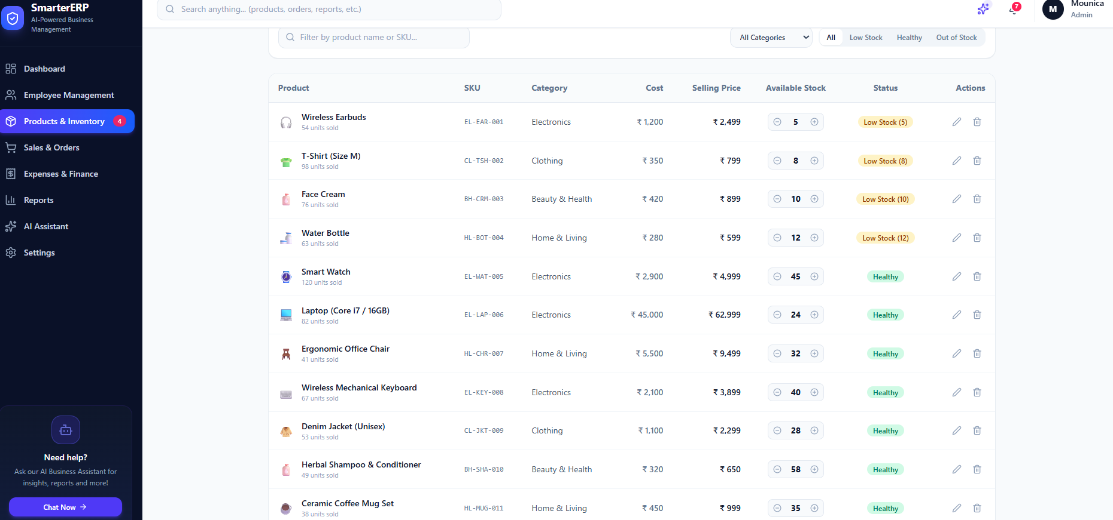

4.4.3 Sales Management Module
The Sales Management module supports the display and management of sales-related information. It can help users review sales records and understand business transactions. Where implemented, sales information can also be used to calculate totals and display summaries on the dashboard.

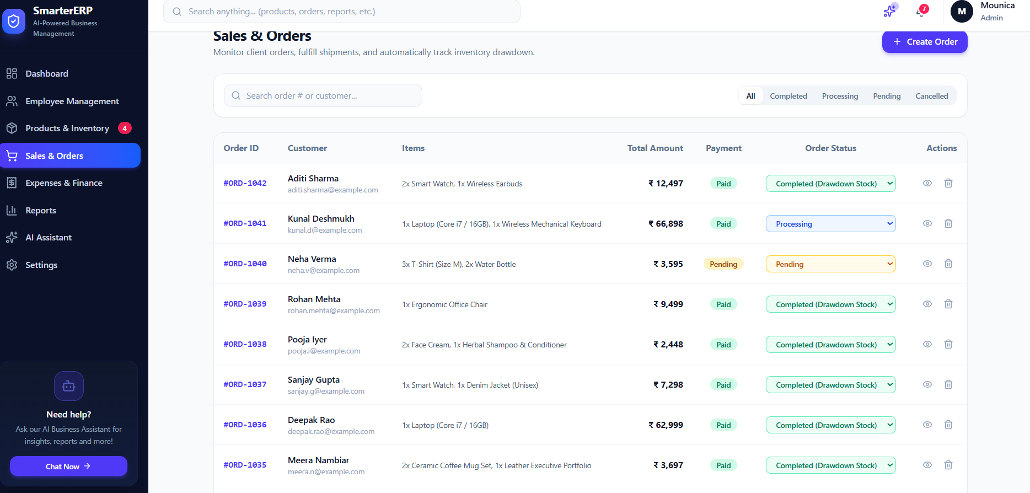

4.4.4 Employee Management Module
The Employee Management module is designed to organize employee-related details. Depending on the implemented features, it may display employee names, roles, departments, and other basic information. It provides a centralized interface for accessing employee records.

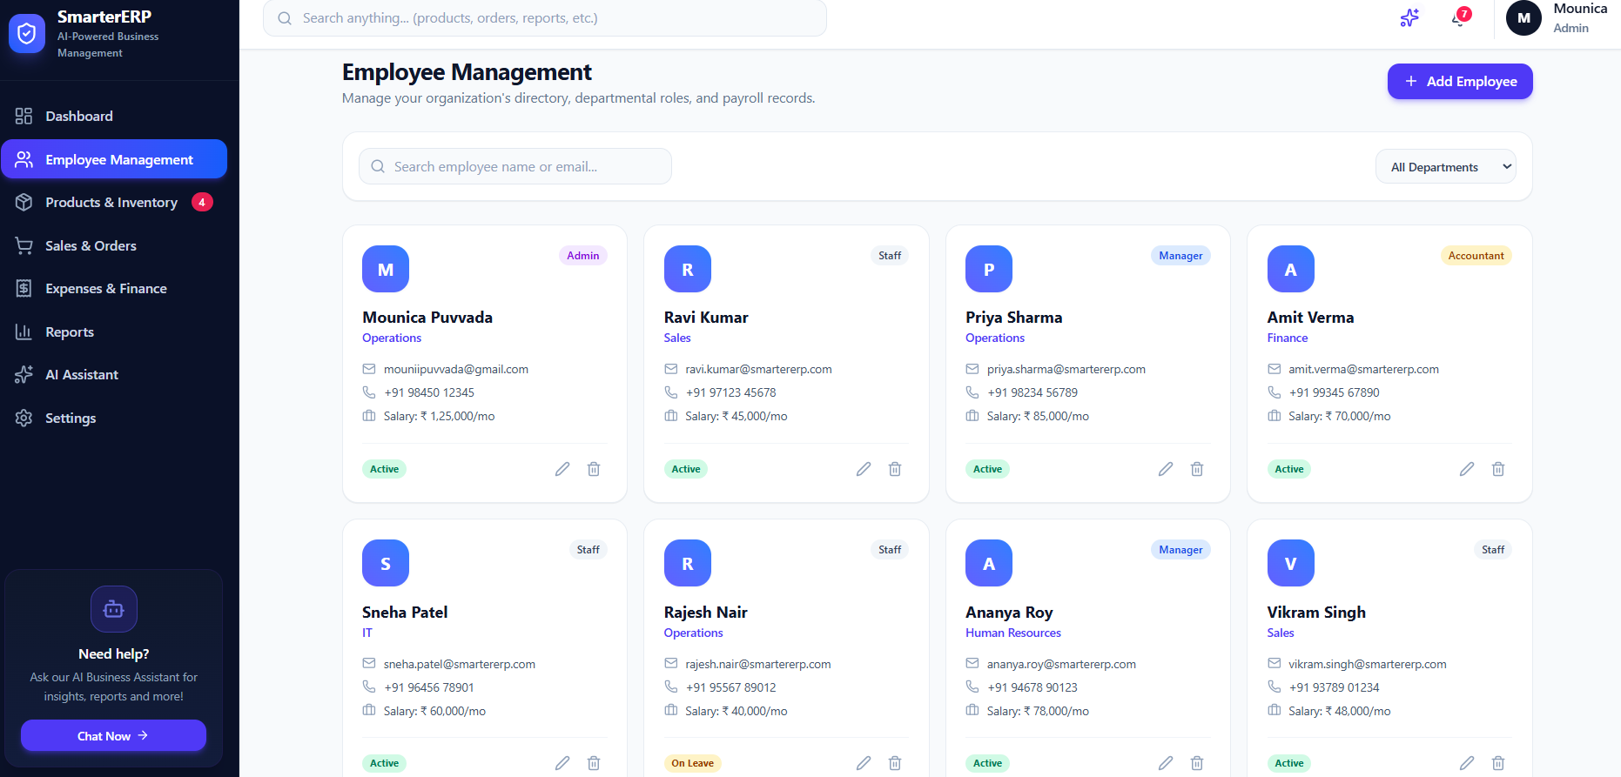

4.4.5 Reports Module
The Reports module is intended to present business information in a summarized format. Reports can help users understand sales activity, inventory status, and other available business data. The usefulness of these reports depends on the information stored and the reporting features implemented in the application.

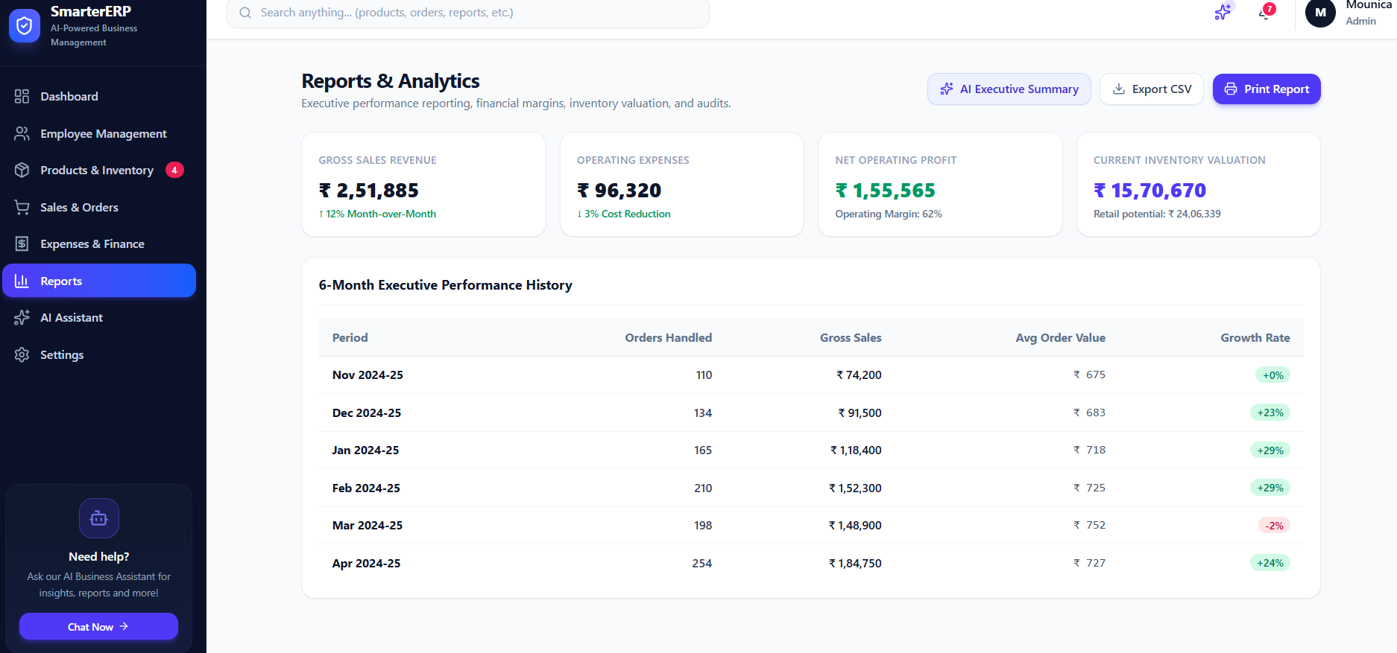

4.4.6 Generative AI Business Assistant Module
The Generative AI Business Assistant provides a chat-style interface for demonstrating how an AI assistant could support business-related queries. It is intended to make the application more interactive and user-friendly.

In the current project version, the assistant operates in demo mode. Therefore, it should not be described as a fully connected live AI service unless an actual AI API has been integrated and tested.

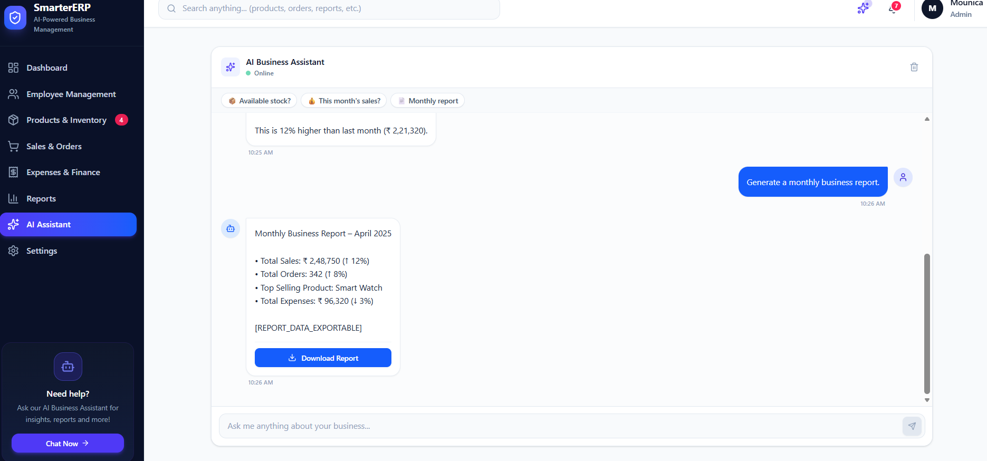

4.5 User Interface Implementation
The user interface is designed to provide simple navigation and easy access to the application's modules. React.js is used to build interactive interface components, while CSS is used to maintain a consistent appearance throughout the application.
The interface may include a navigation sidebar, a header section, dashboard summary cards, module pages, and an AI assistant panel. Responsive styling helps the application adapt to different screen sizes.
The design focuses on readability, consistent spacing, clear navigation, and presenting business information in an organized manner.

4.6 Data Storage Implementation
Browser Local Storage is used to retain supported application data in the user's browser. It allows information to remain available after refreshing the page or reopening the application in the same browser, provided the stored data has not been cleared.
Local Storage is suitable for demonstrating a frontend prototype. However, it is not a replacement for a centralized database in a production ERP system. Data stored in one browser is not automatically shared with other users or devices.
The current implementation should therefore be considered a prototype unless a backend server and centralized database have been separately developed and connected.

4.7 Code Highlights
The main implementation areas of SmartERP include the following:
React components: Components are used to divide the interface into smaller, reusable sections. This improves code organization and simplifies maintenance.
Application logic: JavaScript handles supported user interactions, page behavior, data display, and calculations.
Styling: CSS defines the visual layout, colors, typography, spacing, and responsive behavior.
Local data handling: Browser Local Storage is used for supported data persistence in the frontend.
AI assistant interface: A chat-style interface demonstrates the proposed use of a Generative AI business assistant. In demo mode, its responses do not necessarily come from a live AI model.
These implementation areas work together to provide the main user interface and demonstrate the intended ERP workflow.

4.8 Screenshots of the Application
Screenshots are included to demonstrate the actual appearance and functionality of the SmartERP application. Each screenshot should be captured from the running application and placed below the relevant description.

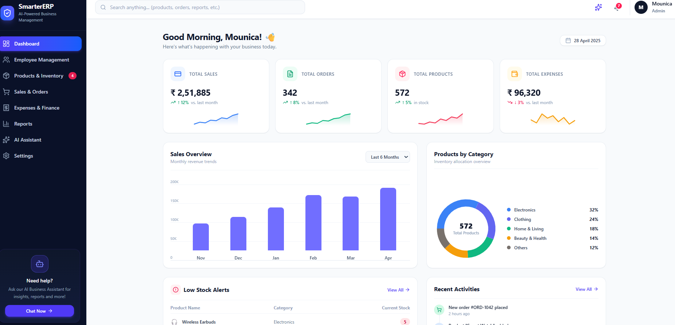
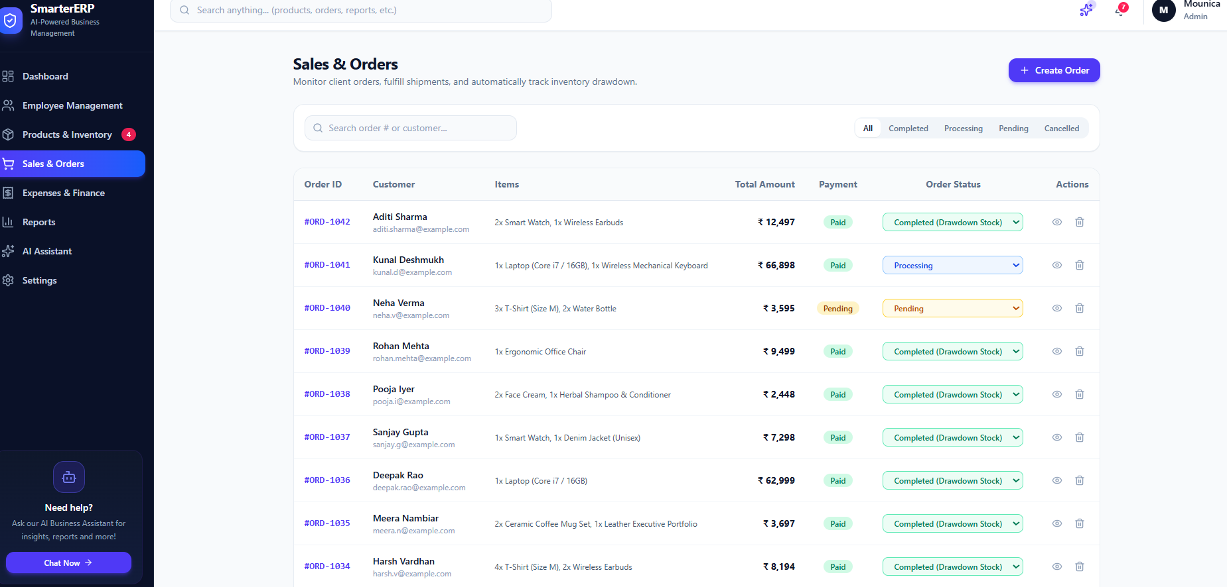
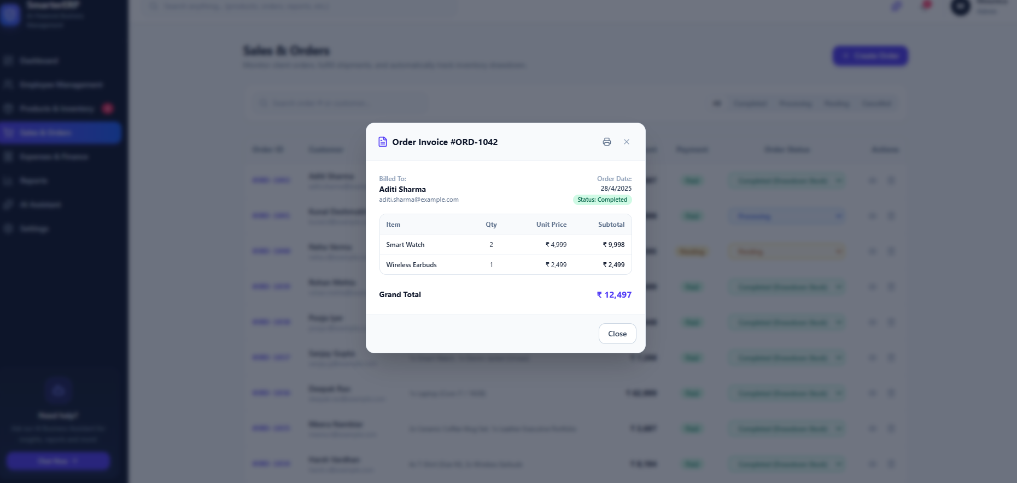
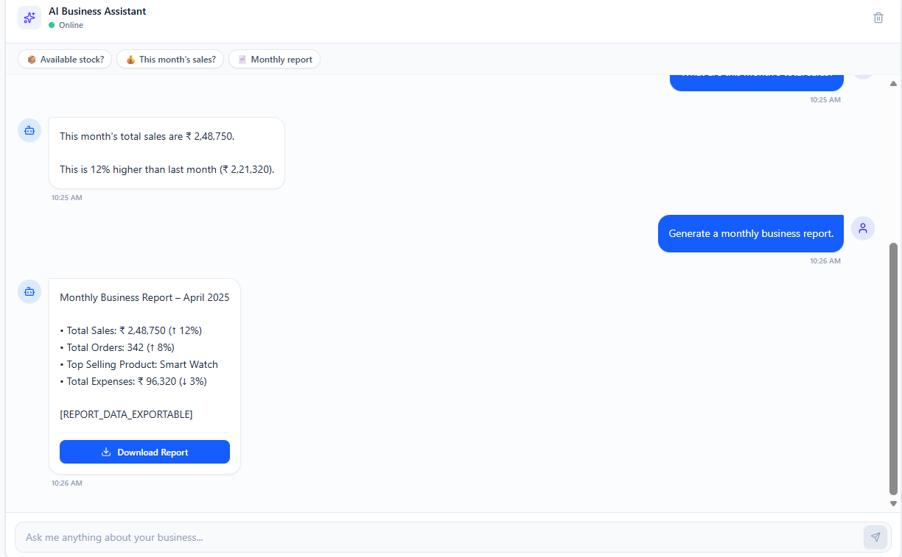

4.9 Summary
This chapter explained the implementation of the SmartERP application, including the technologies used, project structure, major modules, user interface, data storage, and important implementation areas. The project demonstrates how React.js and related frontend technologies can be used to build an ERP-style web application with a business assistant interface. The current prototype provides a foundation for future improvements, such as centralized database integration, secure authentication, and connection to a live Generative AI service.

CHAPTER 5
TESTING, RESULTS & CONCLUSION

5.1 Introduction
Software testing is an important phase in application development. It is performed to verify whether the application works as expected and to identify errors or problems in its functionality. Testing helps ensure that the user interface, navigation, data handling, and available modules operate correctly.
The SmartERP application was tested by running it in a web browser and checking its available features. The testing process focused on page loading, navigation between modules, user interactions, supported data storage, and the demonstration of the Generative AI Business Assistant.

5.2 Testing Objectives
The main objectives of testing the SmartERP application are:
- To verify that the application starts and loads correctly.
- To check whether the dashboard and available modules display properly.
- To verify navigation between different pages and sections.
- To test the user interactions available in each module.
- To check whether supported data is stored and retrieved correctly.
- To verify the display of the AI assistant interface.
- To identify errors and improve the usability of the application.

5.3 Types of Testing

5.3.1 Functional Testing
Functional testing checks whether the implemented features work according to their intended purpose. In SmartERP, this includes checking the dashboard, module navigation, available forms, buttons, and data-related operations.

5.3.2 User Interface Testing
User interface testing verifies the visual appearance and usability of the application. The layout, text, navigation menu, buttons, cards, and other interface elements are checked to ensure that they are displayed clearly.

5.3.3 Integration Testing
Integration testing checks whether different parts of the application work together correctly. In SmartERP, this includes verifying interactions between React components, application logic, browser Local Storage, and the assistant interface wherever applicable.

5.3.4 Compatibility Testing
Compatibility testing checks whether the application can be accessed through supported web browsers and screen sizes. The interface should remain readable and usable on desktop and mobile screens where responsive styling is implemented.

5.3.5 Data Persistence Testing
Data persistence testing checks whether supported information remains available after refreshing the browser. Since the current prototype uses browser Local Storage for supported data, this test applies to the data that is actually saved there.

5.4 Test Cases
The following table presents the test cases used to evaluate the SmartERP application. Update the results based on the tests you actually perform.

Test Case ID | Test Scenario | Expected Result | Status
TC01 | Launch the application | Application loads without errors | To be verified
TC02 | Open the dashboard | Dashboard elements display correctly | To be verified
TC03 | Navigate between modules | Selected module opens correctly | To be verified
TC04 | Click available buttons and links | Correct action is performed | To be verified
TC05 | Enter information in supported forms | Input is handled correctly | To be verified
TC06 | Refresh the application | Supported saved data remains available | To be verified
TC07 | Open the AI assistant | Assistant interface is displayed | To be verified
TC08 | Test responsive layout | Interface remains usable at supported screen sizes | To be verified

5.5 Results and Discussion
The SmartERP project demonstrates an ERP-style web interface that brings business-related features together in one application. Its React-based frontend provides a structured interface for accessing the dashboard and available business modules.
The application also demonstrates a business assistant interface intended to support business-related queries. In the current prototype, the assistant operates in demo mode unless a live AI service has been integrated separately.
Browser Local Storage supports local persistence for the information saved by the application. However, it does not provide centralized data sharing between different users or devices. The current implementation therefore serves as a prototype that demonstrates the design and selected functionality of an ERP application.

5.6 Advantages of the System
The main advantages of SmartERP are:
- Centralized interface: Provides access to available business modules from one application.
- User-friendly design: Organizes information in a clear and accessible layout.
- Interactive frontend: React.js supports reusable components and dynamic user interactions.
- Local data persistence: Supported information can be retained in the browser using Local Storage.
- AI assistant demonstration: Introduces the concept of using an assistant to support business-related tasks.
- Future extensibility: The prototype can be extended with additional modules, backend services, and database integration.

5.7 Limitations of the System
Although SmartERP demonstrates useful ERP concepts, the current prototype has some limitations.
First, browser Local Storage is suitable for local demonstrations but does not provide a centralized database. Second, the AI assistant operates in demo mode and should not be considered a live Generative AI service unless an actual AI model or API is connected. Third, secure authentication, role-based access control, and multi-user data synchronization require additional implementation if they are not already available.
These limitations can be addressed in future versions of the project.

5.8 Future Enhancements
The SmartERP application can be improved in several ways. A backend server and centralized database can be integrated to manage business information across multiple users. Secure login, role-based permissions, and data validation can improve security and reliability.
The demo assistant can be connected to a live Generative AI API to provide context-aware answers based on permitted business data. Additional features such as advanced reporting, automated notifications, inventory alerts, financial summaries, and exportable reports can also be introduced.
These enhancements would help transform the current prototype into a more complete business management solution.

5.9 Conclusion
SmartERP – ERP with Generative AI Business Assistant is a project developed to demonstrate how web technologies can be used to create an integrated business management interface. The application uses React.js, JavaScript, CSS, and Vite to provide an interactive frontend, while browser Local Storage supports local persistence for the data saved by the application.
The project provides a foundation for organizing business-related features and demonstrating the potential role of an AI assistant in an ERP environment. The development process also provides practical experience in frontend development, component-based architecture, interface design, and software testing.
In conclusion, SmartERP demonstrates the basic structure and potential of an ERP-style application. With further development, including centralized database integration, secure authentication, and a live AI service, it could be extended into a more comprehensive business management system.

5.10 References
The following resources can be included in the project documentation:

- React.js Official Documentation — https://react.dev/

- JavaScript Documentation — MDN Web Docs

- HTML and CSS Documentation — MDN Web Docs

- Vite Official Documentation — https://vite.dev/

- Web Storage API Documentation — MDN Web Storage API

- Check My Project- https://smartererp.ai.studio

- http://localhost:3000
APPENDIX A – GLOSSARY OF TERMS
This appendix explains the technical terms used in the SmartERP project.
Term | Description
ERP | Enterprise Resource Planning; a system used to manage different business activities.
SmartERP | The name of the proposed ERP-style web application.
AI | Artificial Intelligence; technology that enables computers to perform tasks that normally require human intelligence.
Generative AI | Artificial Intelligence that can generate text and other content based on input.
React.js | A JavaScript library used to build user interfaces.
JavaScript | A programming language used to implement interactive web application functionality.
HTML | HyperText Markup Language, used to structure web pages.
CSS | Cascading Style Sheets, used to style web pages.
Vite | A frontend development and build tool.
UI | User Interface; the part of the application that users interact with.
Local Storage | Browser storage used to retain data locally on a device.
Dashboard | A screen that displays a summary of important information.
Module | A separate section of an application designed for a particular function.
Testing | The process of checking whether an application works as expected.
Responsive Design | An approach that makes a website usable on different screen sizes.
API | Application Programming Interface; a way for software components to communicate.
Prototype | An early version of an application used to demonstrate its design and functionality.

APPENDIX B – QUICK USER MANUAL

B.1 Introduction
The Quick User Manual explains how to open and use the SmartERP application. It provides basic instructions for navigating the interface and accessing its available features.

B.2 System Requirements
The following requirements are recommended for accessing the application.
- A desktop computer, laptop, tablet, or smartphone.
- A modern web browser such as Google Chrome or Microsoft Edge.
- An internet connection if the application is hosted online.
- Node.js and npm if the project is being run locally using Vite.

B.3 Steps to Run the Application
For a locally stored project:
- Open the SmartERP project folder in Visual Studio Code.
- Open the VS Code terminal.
- Install the required packages if they have not already been installed by running:
npm install
- Start the development server:
npm run dev
- Open the local URL displayed in the terminal, usually http://localhost:5173/.
- The SmartERP application will open in the browser.
If the application is already deployed online, open its deployment URL directly.

B.4 Using the Application

Step 1: Open the Dashboard
Open the application in the browser. The dashboard provides an overview of the information and modules available in the current version.
Step 2: Navigate Through Modules
Use the navigation menu to access the available business sections. Select a module to view its interface and supported functionality.
Step 3: View Business Information
Open the relevant module to view the available information. Use the provided buttons, forms, or other controls to interact with the application.
Step 4: Use the AI Assistant
Open the Generative AI Business Assistant interface and enter a query if the demo interface supports text input. The current version demonstrates the assistant concept in demo mode unless a live AI service has been connected.
Step 5: Check Saved Information
For features that use browser Local Storage, refresh the page to check whether the saved information remains available. Stored information is local to that browser and device.

B.5 Troubleshooting

Problem | Suggested Solution
Application does not open | Check the development server and browser URL.
Packages are missing | Run npm install inside the project folder.
Page displays an error | Check the terminal and browser console for error messages.
Saved information is missing | Check whether browser data was cleared or the application uses Local Storage for that information.
AI assistant gives demo responses | This is expected when a live AI service has not been connected.

APPENDIX C – DEFAULT SAMPLE DATA
This appendix provides example data that can be used to demonstrate the SmartERP interface. The values below are illustrative sample records and are not actual business records.

C.1 Sample Product Data

Product ID | Product Name | Category | Unit Price (₹) | Stock Quantity
P001 | Laptop | Electronics | 45,000 | 10
P002 | Wireless Mouse | Accessories | 800 | 25
P003 | Keyboard | Accessories | 1,200 | 18
P004 | Office Chair | Furniture | 5,500 | 8
P005 | Printer | Electronics | 12,000 | 6

C.2 Sample Sales Data

Order Id | Customer Name | Items | Total Amount | Payment
ORD-1042 | Aditi Sharma | 2 Smart Watches, 1 Wireless Earbuds | ₹12,497 | Paid
ORD-1041 | Kunal Deshmukh | 1 Laptop, 1 Mechanical Keyboard | ₹66,898 | Paid
ORD-1040 | Neha Verma | 3 T-Shirts, 2 Water Bottles | ₹3,595 | Pending
ORD-1039 | Rohan Mehta | 1 Office Chair | ₹9,499 | Paid
ORD-1038 | Pooja Iyer | Face Cream, Herbal Shampoo & Conditioner | ₹2,448 | Paid
ORD-1037 | Sanjay Gupta | 1 Smart Watch, 1 Denim Jacket | ₹7,298 | Paid
ORD-1036 | Deepak Rao | 1 Laptop | ₹62,999 | Paid
ORD-1035 | Meera Nambiar | Coffee Mug Sets, Executive Portfolio | ₹3,697 | Paid
ORD-1034 | Harsh Vardhan | 4 T-Shirts, 2 Wireless Earbuds | ₹8,194 | Paid
ORD-1033 | Shreya Banerji | 2 Office Chairs, 1 Mechanical Keyboard | ₹22,897 | Paid
ORD-1032 | Arjun Pillai | 3 Smart Watches | ₹14,997 | Paid

C.3 Sample Employee Data

Order Status | Description
Pending | The order is waiting to be processed.
Processing | The order is being prepared.
Completed | The order has been completed.
Cancelled | The order has been cancelled.

C.4 Sample Expense Data

Order ID | Customer | Total Amount | Payment Status | Sales Status
ORD-1042 | Aditi Sharma | ₹12,497 | Paid | Pending
ORD-1041 | Kunal Deshmukh | ₹66,898 | Paid | Processing
ORD-1040 | Neha Verma | ₹3,595 | Pending | Pending
ORD-1039 | Pooja Iyer | ₹9,499 | Paid | Paid

C.5 Purpose of Sample Data
The sample data demonstrates how product, sales, employee, and expense information can be organized in an ERP-style application. It can be used for interface demonstrations, sample reports, and testing data display or calculation features.

